NAME : SAAD SALMAN DAR

ROLL NUMBER : L1S23BSCS0324

DBMS ASSIGNMENT 2

Q1.

create database assignment2;

use assignment2;

create table BOOK(

Book_id int,

Title varchar(255) not null,

Publisher_name varchar(255),

constraint pk_BOOK primary key(Book_id)

);

show columns from BOOK;

SELECT* FROM BOOK;

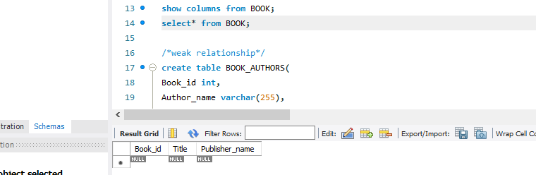

/*weak relationship*/

create table BOOK_AUTHORS(

Book_id int,

Author_name varchar(255),

constraint pk_BOOK_AUTHORS primary key(Book_id , Author_name),

constraint fk_BOOK_BOOK_AURHTOS foreign key(Book_id) references BOOK(Book_id) on update cascade on delete cascade

);

show columns from BOOK_AUTHORS;

SELECT* FROM BOOK_AUTHORS;

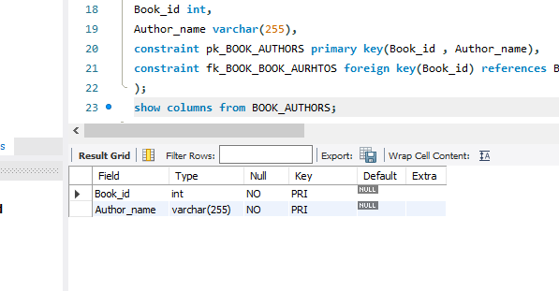 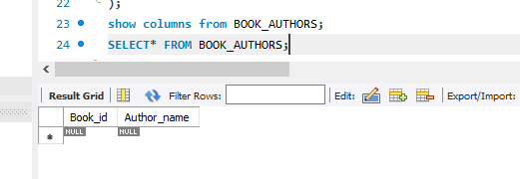

/* on deletion of the book pk , in this table the respective tuple having author name will also delete(the entire column will) thus showing

the existance of the book_author entries are entirely reliant on the book id and would cease to exist without them*/

create table PUBLISHER(

Name varchar(255),

Address varchar(255),

Phone varchar(255),

constraint pk_PUBLISHER primary key(Name)

);

SHOW COLUMNS FROM PUBLISHER;

SELECT* FROM PUBLISHER;

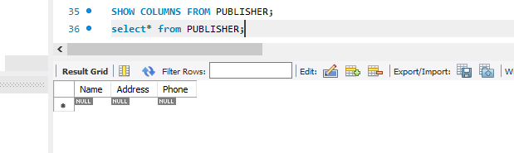

/* creating reference between publisher_name residing in the book relation with the publisher table*/

show columns from BOOK;

alter table BOOK

ADD CONSTRAINT fk_PUBLISHER_BOOK foreign key(Publisher_name) references PUBLISHER(Name) on update cascade on delete set null;

show columns FROM BOOK;

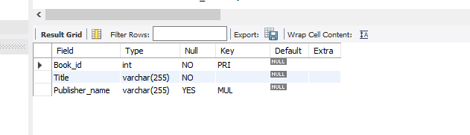

SELECT* FROM BOOK;

/* many->many relationship a seperate table will be created.

a book can be in many brancHes and a branch can have many copies of same book.*/

create table BOOK_COPIES(

Book_id int,

Branch_id int,

No_of_copies int,

constraint pk_BOOK_COPIES primary key(Book_id , Branch_id),

constraint fk_BOOK_BOOK_COPIES foreign key(Book_id) references BOOK(Book_id) on update cascade on delete cascade

/* if the books get's deleted from our database no need of keeping it's info about it's copies in our database*/

);

show columns from BOOK_COPIES;

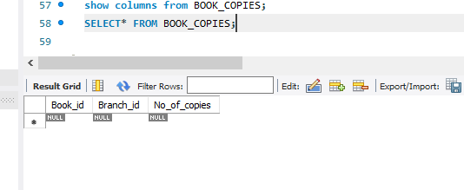

create table LIBRARY_BRANCH(

Branch_id int,

Branch_name varchar(255) not null,

Address varchar(255) not null,

constraint pk_LIBRARY_BRANCH primary key(Branch_id)

);

show columns fROM LIBRARY_BRANCH;

SELECT* FROM LIBRARY_BRANCH;

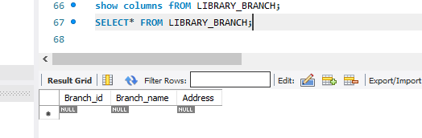

/* creating reference of the foreign key of library_branch residing in the book_copies table*/

alter table BOOK_COPIES

ADD CONSTRAINT fk_LIBRARY_BRANCH_BOOK_COPIES foreign key(Branch_id) references LIBRARY_BRANCH(Branch_id) on update cascade on delete cascade;

show columns from BOOK_COPIES;

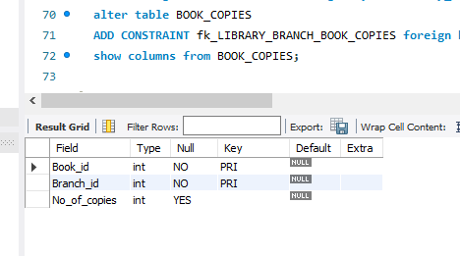

create table BORROWER(

Card_no int,

Name varchar(255),

Address varchar(255),

Phone int,

constraint pk_BORROWER primary key(Card_no)

);

show columns FROM BORROWER;

SELECT* FROM BORROWER;

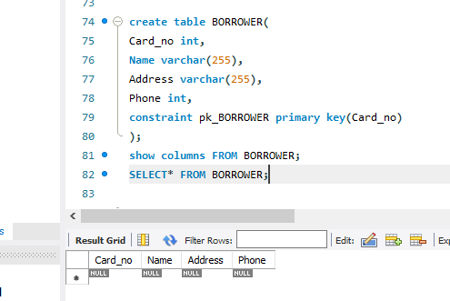

/* TERTIARY RELATIONSHIP BETWEEN BOOK_ID , BRANCH_ID , CARD_NO ALL ARE REQUIRED TO KEEP INFO ABOUT THE BOOKS LOANED OUT AND EXTRA INFO LIKE DATE_OUT AND DUE_DATE COMES TO US BECUASE OF THESE RELATIONSHIP ;)

/* I WILL TRY IMPLEMENTING ON DELETE RESTRICT FOR THIS , WHAT THIS QUERY WILL DO IS STOP THE DELETION OF BOOK , BORROWER AND BRANCH INFO IF THE SPECIFIC BOOK IS LOANED OUT ALL THE INFO RELATED TO IT WILL NOT BE ABLE TO BE DELETED. BOOK_LOAN WALEY RELATIONSHIP K PASS IKHTEYAAR AJATA HAE AND

IT DOES NOT ALLOWS FOR IT TO BE DELETED.*/

CREATE TABLE BOOK_LOANS(

Book_id int,

Branch_id int,

Card_id int,

Date_out date not null,

Due_date date not null,

constraint pk_BOOK_LOANS primary key(Book_id , Branch_id , Card_id),

constraint fk_BOOK_BOOK_LOANS foreign key(Book_id) references BOOK(Book_id) on update cascade on delete restrict,

constraint fk_LIBRARY_BRANCH_BOOK_LOANS foreign key(Branch_id) references LIBRARY_BRANCH(Branch_id) on update cascade on delete restrict,

constraint fk_BORROWER_BOOK_LOANS foreign key(Card_id) references BORROWER(Card_no) on update cascade on delete restrict

);

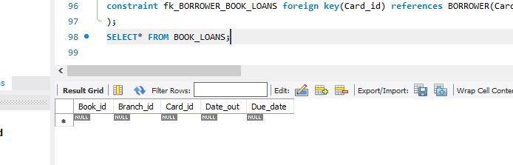

Q2.

/*<<<<<<<<<< Q2 INSERTING VALUES INTO THE DATABASE >>>>>>>>>>>>>>>>*/

show columns from BOOK;

insert into BOOK

value

(8000 , 'Don Quixote' , null ),

(8001 , 'A Tale of Two Cities' , null),

(8002 , 'The Lord of Rings' , null ),

(8003 , 'And Then There Were None' , null ),

(8004 , 'The Hobbit' , null);

select* from BOOK;

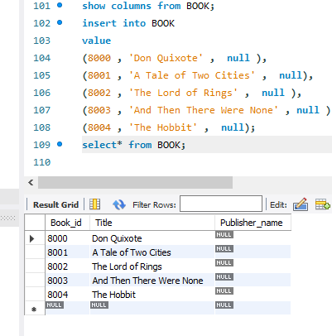

insert into BOOK_AUTHORS

value

(8000 , 'Harper Lee'),

(8001 , 'George Onwell'),

(8002 , 'F. Scott Fitzgerald'),

(8003 , 'J.D. Salinger'),

(8004 , 'Jane Austen');

SELECT* FROM BOOK_AUTHORS;

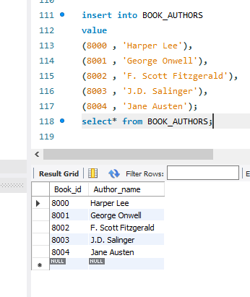

insert into PUBLISHER

values

('Penguin Books' , '123 Penguin Lane,London<,UK' , 04231234567),

('HarperCollins' , '95 Broadway, New York, NY, USA' , 04239999999),

('Simon & Schuster' , '1234 Schuster Blvd, Los Angeles, CA, USA' , 04231111111),

('Hachette Book Group' , '5678 Hachette Street, Paris, France' , 04232222222),

('Macmillan Publishers' , '25 Bedford Square, London, UK' , 04233333333);

SELECT* FROM PUBLISHERS;

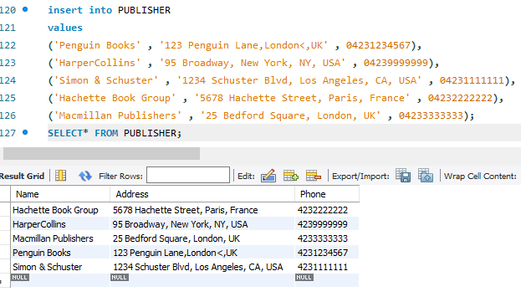

-- adding values of the publishers in the books column

update BOOK

SET Publisher_name = 'Penguin Books'

where Book_id=8000;

update BOOK

SET Publisher_name = 'HarperCollins'

where Book_id>=8001 and Book_id<=8004;

select* from BOOK;

update BOOK

set publisher_name = 'Hachette Book Group'

where book_id = 8004;

update BOOK

set publisher_name = 'Macmillan Publishers'

where book_id = 8003;

SELECT* FROM BOOK;

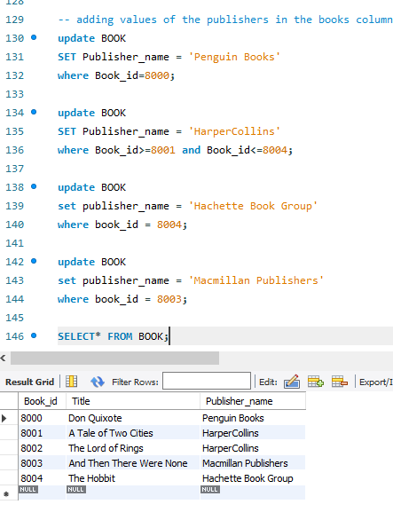

-- adding values to the relation library_branch

show columns FROM LIBRARY_BRANCH;

INSERT INTO LIBRARY_BRANCH

VALUES

(900 , 'Central Library' , '123 Main Street'),

(901 , 'Westdie Library' , '456 Elm Aveneue'),

(902 , 'Eastend Library' , '786 Oak Boulevard'),

(903 , 'Southside Library' , '321 Pine Drive'),

(904 , 'North Hill Library', '654 Maple Lane');

select* from LIBRARY_BRANCH;

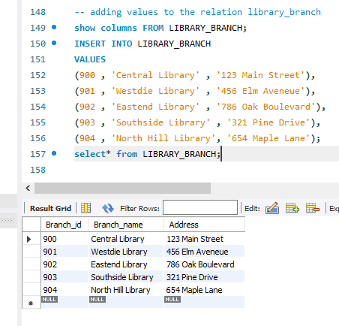

-- ADDING VALUES INTO BOOK_COPIES --

SHOW COLUMNS FROM BOOK_COPIES;

INSERT INTO BOOK_COPIES

VALUES

(8000 , 900 , 10),

(8000 , 901 , 12),

(8000 , 904 , 2),

(8001 , 902 , 4),

(8001 , 903 , 5),

(8002 , 902 , 8),

(8002 , 904 , 15),

(8003 , 900 , 1),

(8003 , 904 , 4),

(8004 , 903 , 2),

(8004 , 902 , 5),

(8004 , 901 , 1);

SELECT* FROM BOOK_COPIES;

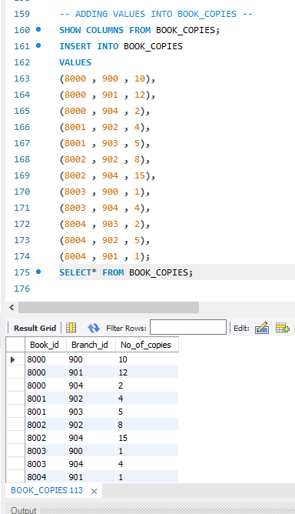

-- ADDING VALUES INTO BORROWER RELATION

-- exceeding the given limit of 2,147,483,647 , so converting int to varchar to store numbers of the users

alter table BORROWER

MODIFY Phone varchar(255);

show columns fROM BORROWER;

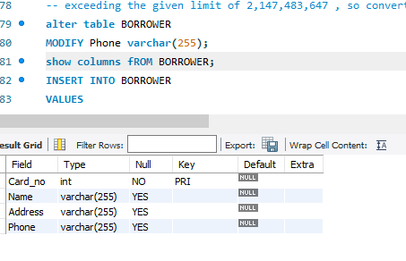

INSERT INTO BORROWER

VALUES

(1 ,'Saad Salman Dar' , '24 Usman Block , Bahria Town , Lhr' , '+923241234567'),

(2 , 'Ali Asghar' , '530 Tariq Block , Wapda Town , Lhr' , '+923224501111'),

(3 , 'Naila Haroon' , '243 Chambeli Block , Garden Town , Lhr', '+923421963953'),

(4 , 'Haroon Pasha Dar' , '93 New Shadman , Lhr' , '+923459279053'),

(5 , 'Hasnat Hammad' , '24 College Block , Iqbal Town , Lhr' , '+923124444444');

SELECT* FROM BORROWER;

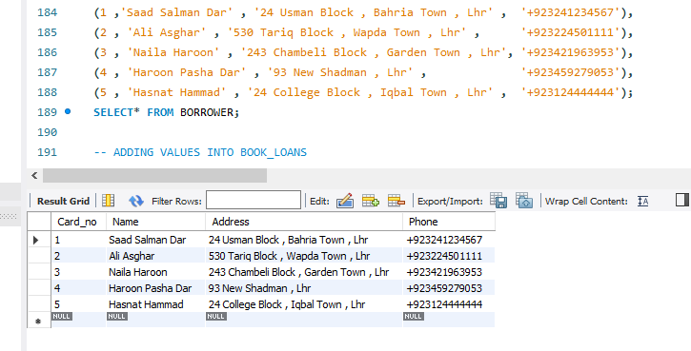

-- ADDING VALUES INTO BOOK_LOANS

INSERT INTO BOOK_LOANS

VALUES

(8000 , 900 , 1 , '2022-10-01' , '2022-10-30'),

(8001 , 901 , 2 , '2022-09-02' , '2022-09-30'),

(8002 , 902 , 3 , '2022-10-05' , '2022-11-15'),

(8003 , 903 , 4 , '2022-02-28', '2022-05-05'),

(8004 , 904 , 5 , '2022-03-03' , '2022-04-04');

SELECT* FROM BOOK_LOANS;

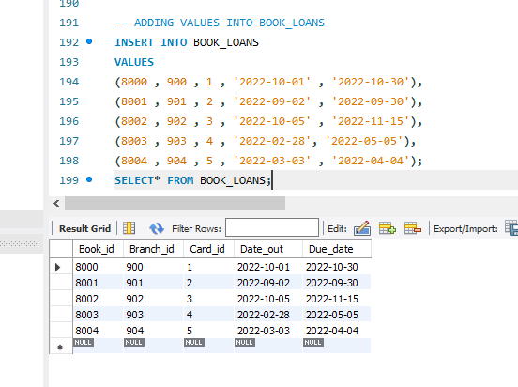

Q3

-- Q3 QUERIES

-- 1

-- using the join keyword to solve this problem , although have not studied it yet ;(

insert into BOOK_COPIES

VALUES

(8004, 904 , 20),

(8003 , 902 , 25),

(8004 , 900 , 24);

INSERT INTO BOOK_COPIES

VALUES

(8002 , 901 , 15),

(8001 , 900 , 11),

(8002 , 903 , 12);

INSERT INTO BOOK_COPIES

VALUES

(8001 , 904 , 14),

(8004 , 904 , 20);

SELECT B.Title, B.Book_id, P.Name AS Publisher, P.Address, BC.No_of_copies

FROM BOOK B

JOIN BOOK_COPIES BC

ON B.Book_id = BC.Book_id

JOIN PUBLISHER P

ON B.Publisher_name = P.Name

WHERE BC.Branch_id = 904

AND BC.No_of_copies > 10

AND P.Address LIKE '%New York%';

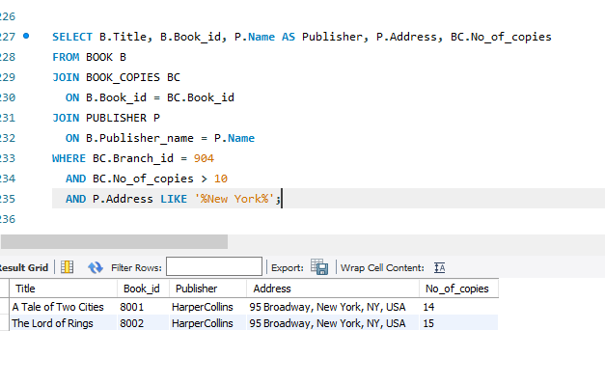

-- 2

-- THE REQUIRED DIDNOT EXIST SO I ADDED THE INFO ACCORDING TO THE REQUIREMENTS AND THEN I CALLED THE QUERY.

insert into BORROWER

VALUES

(6 , 'ALISHBAH ASGHAR' , '234 CHICHAWATNI , LHR' , '+923331234789');

SELECT* FROM BORROWER;

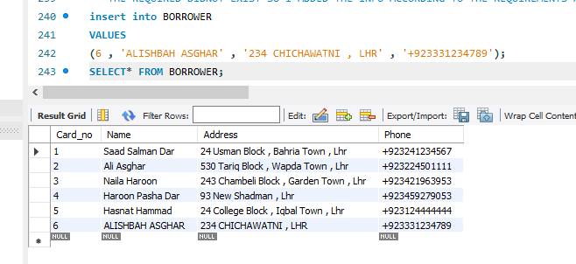

select*

from BORROWER

WHERE Name like 'A%' and Phone like '%789';

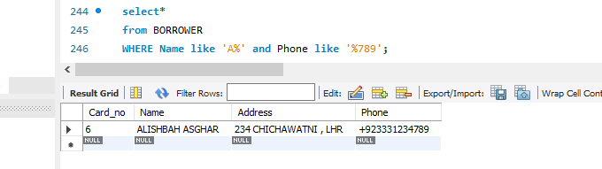

-- 3

-- ADDING THE REQUIRED VALUES INTO THE DATABASE ACCORDING TO THE CONDITION

INSERT INTO BOOK_LOANS

VALUES

(8004 , 902 , 1 , '2024-02-02' , '2024-02-28'),

(8003 , 901 , 2 , '2024-01-01' , '2024-02-15');

SELECT* FROM BOOK_LOANS;

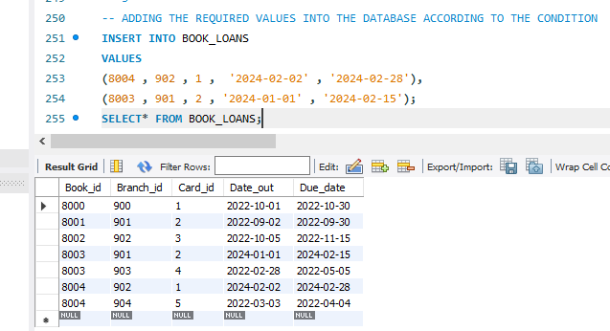

SELECT*

FROM BOOK_LOANS

WHERE Due_date>='2024-01-01' and Due_date<='2024-03-01';

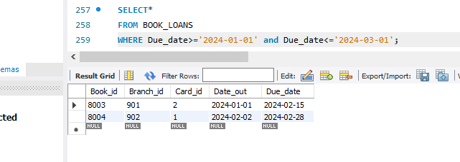

-- 4

SELECT* FROM BOOK;

insert into BOOK

VALUES

(8005 , 'Intro to Programming' , null),

(8006 , 'Programming Fundamentals' , null);

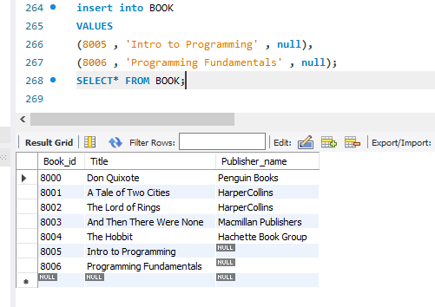

SELECT* FROM PUBLISHER;

insert into PUBLISHER

VALUES

('DS MALIK' , '234 New Muslim Town , Lhr' , 0312444123);

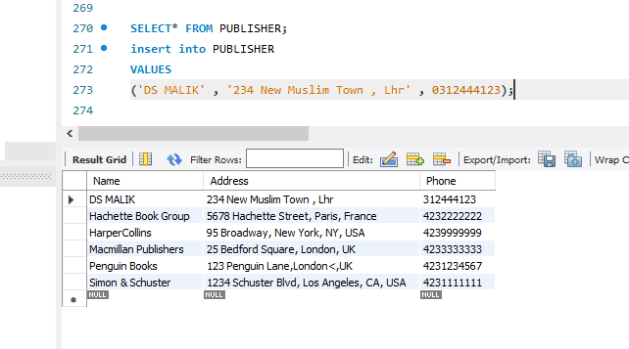

update BOOK

SET Publisher_name = 'DS MALIK'

where Title like '%Programming%';

SELECT* FROM BOOK;

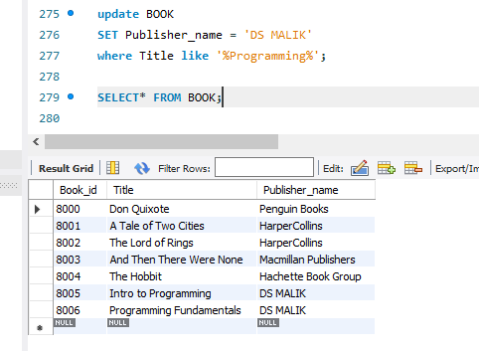

SELECT*

FROM BOOK

WHERE TITLE LIKE '%PROGRAMMING%';

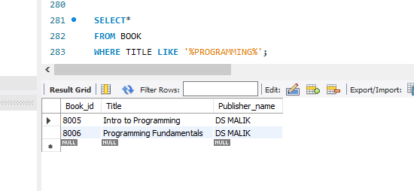

-- 5

SELECT*

FROM PUBLISHER

WHERE NAME NOT LIKE 'M%';

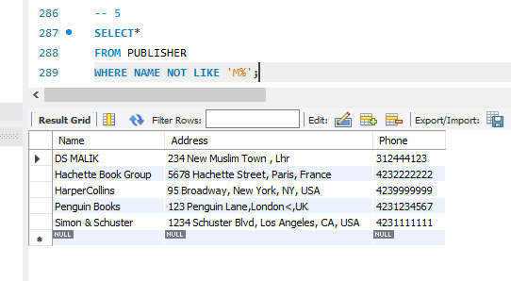

-- 6

SELECT Name

FROM BORROWER

order by Name;

select* from BOOK;

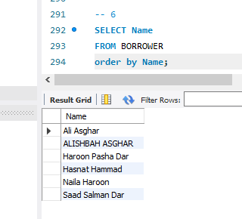

-- 7

-- I HAVE A TOTAL OF 7 BOOKS I HAVE TO CALL ONLY THE FIRST 5 (ORDER BY NAME)

-- i am using the limit at the end of the query to limit the number of titles presented to 5

SELECT Title

from BOOK

order by Title

limit 5;

